Chapter 6: Dictionaries

What is a Dictionary?
- A dictionary stores related information using key–value pairs
- Written using curly braces {}
- Syntax:
- my_dict = {'key': 'value'}
- Keys are unique
- Values can be:
  - strings
  - numbers
  - lists
  - dictionaries
  - any Python object

Why Use Dictionaries?
- Model real-world objects more accurately
- Store multiple attributes of one object (e.g., a person)
- Match two related values (e.g., word → meaning, name → age)

Simple Dictionary Example
alien_0 = {'color': 'green', 'points': 5}
print(alien_0['color']) # green
print(alien_0['points']) # 5

Key-Value Pairs
- Format:
key : value
- Multiple pairs separated by commas
- Example:
{'color': 'green', 'points': 5}

Accessing Values
- Use square brackets []
alien_0['color']
- Example:
new_points = alien_0['points']

Adding New Key-Value Pairs
- Dictionaries are dynamic
alien_0['x_position'] = 0
alien_0['y_position'] = 25

Dictionary Order
- From Python 3.7+, dictionaries keep insertion order

Starting with an Empty Dictionary
alien_0 = {}
alien_0['color'] = 'green'
alien_0['points'] = 5
- Useful for:
  - user input
  - auto-generated data

Modifying Values
alien_0['color'] = 'yellow'

Example: Movement Based on Speed
if alien_0['speed'] == 'slow':
x_increment = 1
elif alien_0['speed'] == 'medium':
x_increment = 2
else:
x_increment = 3

Removing Key-Value Pairs
- Use del
del alien_0['points']
⚠️ Removal is permanent

Dictionary of Similar Objects
Example: Favorite programming languages
favorite_languages = {
'jen': 'python',
'sarah': 'c',
'phil': 'python',
}

Using get() Method
- Prevents KeyError
alien_0.get('points', 'No point value assigned.')
- If key not found:
  - returns default value
  - or None if no default given

Looping Through a Dictionary
1) Loop Through Key-Value Pairs
for key, value in user_0.items():
print(key, value)

2) Loop Through Keys
for name in favorite_languages.keys():
print(name)
- .keys() is optional:
for name in favorite_languages:

3) Loop Through Values
for language in favorite_languages.values():
print(language)

Using set() with Values
- Removes duplicates
for language in set(favorite_languages.values()):
print(language)

Sorting Dictionary Keys
for name in sorted(favorite_languages.keys()):
print(name)

Refer to Chapter 6.6 (Try it yourself)
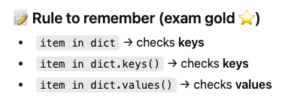

Nesting (Very Important!)

NOTE
You should not nest lists and dictionaries too deeply. If you’re nesting items much deeper than what you see in the following examples or you’re working with someone else’s code with significant levels of nesting, most likely a simpler way to solve the problem exists.

🔸 Dictionaries in a List

The alien_0 dictionary contains a variety of information about one alien, but it has no room to store information about a second alien, much less a screen full of aliens. How can you manage a fleet of aliens? One way is to make a list of aliens in which each alien is a dictionary of information about that alien.

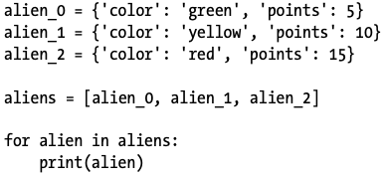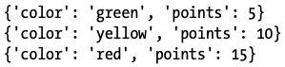

More realistic example would involve more than 3 aliens

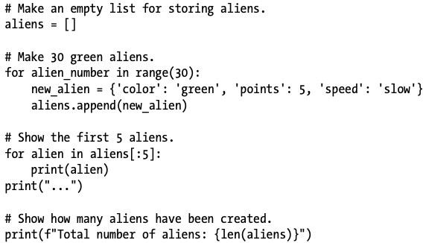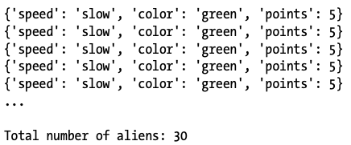

Example if you need to change the color of certain aliens
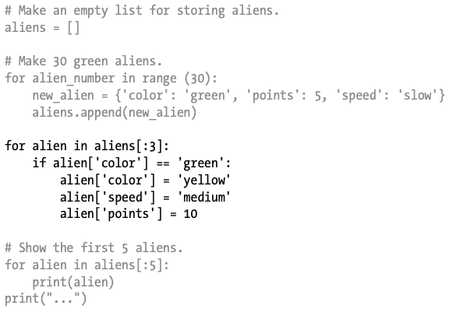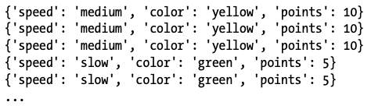

🔸 Lists in a Dictionary
Rather than putting a dictionary inside a list, it’s sometimes useful to put a list inside a dictionary. For example, consider how you might describe a pizza that someone is ordering. If you were to use only a list, all you could really store is a list of the pizza’s toppings. With a dictionary, a list of toppings can be just one aspect of the pizza you’re describing.

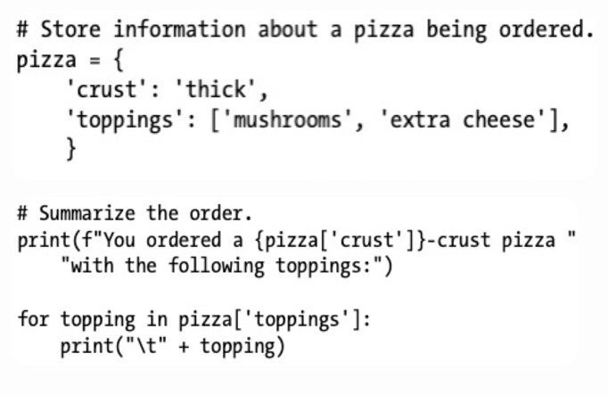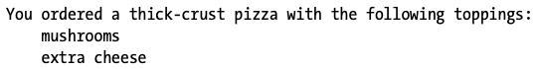

You can nest a list inside a dictionary any time you want more than one value to be associated with a single key in a dictionary. In the earlier example of favorite programming languages, if we were to store each person’s responses in a list, people could choose more than one favorite language. When we loop through the dictionary, the value associated with each person would be a list of languages rather than a single language. Inside the dictionary’s for loop, we use another for loop to run through the list of languages associated with each person:

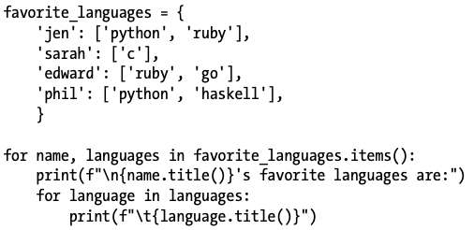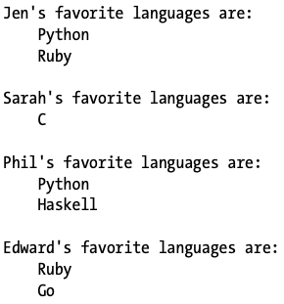

🔸 Dictionary Inside a Dictionary
You can nest a dictionary inside another dictionary, but your code can get complicated quickly when you do. For example, if you have several users for a website, each with a unique username, you can use the usernames as the keys in a dictionary. You can then store information about each user by using a dictionary as the value associated with their username. In the following listing, we store three pieces of information about each user: their first name, last name, and location. We’ll access this information by looping through the usernames and the dictionary of information associated with each username:

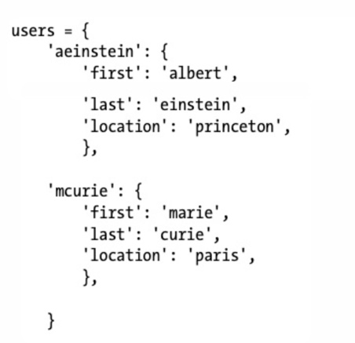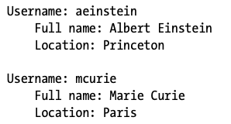

Best Practices
- Keep nested structures simple
- Use consistent keys in nested dictionaries
- Avoid deep nesting if possible
- Use meaningful variable names

Key Takeaways
- Dictionaries store related data
- Use keys to quickly access values
- Can add, modify, delete items anytime
- Support powerful looping techniques
- Nesting allows complex real-world modeling

